One Word: Possibilities
55th Annual Heart of the North Women’s Retreat (Women of all ages!)
August 12 & 13, 2019
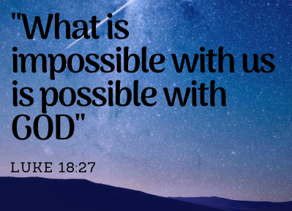
Retreat Pastor/Bible Study: Pastor Maggie Isaacson, North Valley Church, Milltown, WI
Guest Speaker from LifeSpring Home
Musical Guest: Sarah Joosten
Luther Park Bible Camp – Chetek, WI

Take 24 hours to strengthen your relationship with other Christian women and with the triune God
(Monday registration at 1:00 pm, program beginning at 1:45 pm)
If you have never attended, this is the time!
Only $65.00 for 2 days or $35.00 for one day
(Monday program begins at 1:45 pm. Tuesday program begins at 7:45 am)
For More Information contact:
Joan Gerland at 715-205-3100 or jlgerland@gmail.com

